August 30, 2021

Dear Members of the Mt. Vernon Community School Board,

We have recently received notification from the Wyman family and the Fortville American Legion that they would like to donate $500 each to the Mt. Vernon High School Theatre Department . Their intention is that the funds be used to help with expenses for the fall musical. I kindly ask that the board accept these donations to help support the students of MVHS.

Best regards,
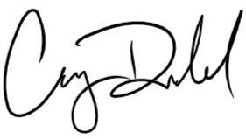
Casey Dodd, Principal

