September 3, 2021

Dear Members of the Mt. Vernon Community School Board,

We have recently received a donation from the Indianapolis Colts Foundation given to the high school athletic department. I kindly ask that the board accept these donations to help support the students of MVHS.

Best regards,
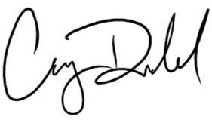
Casey Dodd, Principal

