November 9, 2021

Dear Members of the Mt. Vernon Community School Board,

We have recently received notification from Mr. Bernie Baldwin of Baldwin Excavating that his company would like to donate $500.00 to help support the MVHS Lady Marauders Basketball Program. I kindly ask that the board accept this donation for the members of the MVHS Girls Basketball Program.

Best regards,
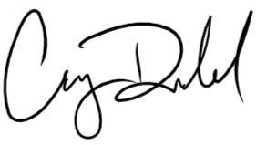
Casey Dodd, Principal

