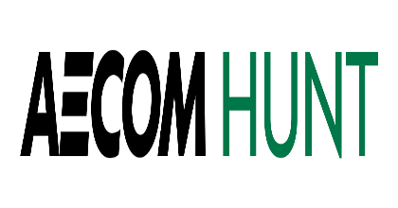
September 16, 2022
Greg Elkins
Chief Financial Officer
Mt. Vernon Community School Corporation
1806 W State Road 234
Fortville, IN 46040

Re: Recommendation of Award for the New Fortville Elementary Project

Dear Mr. Elkins:

AECOM Hunt has received bids for the Mt. Vernon Community School Corporation (MVCSC) “New Fortville Elementary Project – Early Release” as designed by Lancer + Beebe, LLC, on August 31, 2022 at 11:00 AM EST.

On September 1st, we held de-scope meetings with the low bidders. Based on our review of these bids and the de-scope meetings held, we are recommending award to the bidder below.

BP #01 - Mass Excavation, Grading, & Site Utilities
to Millennium Contractors, LLC

Base bid amount $5,300,000

Total Recommended Award $5,300,000

Please advise should you have any further comments or questions relative to the above.

Sincerely,
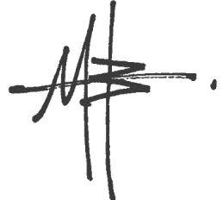
AECOM HUNT Lancer + Beebe, LLC

James D. Gulley Mark Beebe
Project Executive Principal in Charge

CC: Jack Parker, Chris Smedley, Derek Shelton, – MVCSC
Eric Howe. Luke Johnson, Wyatt May, Justin Wolf – AECOM Hunt
Terry Lancer, Misha Belyayev – L+B, LLC
Alyssa Prazeau – Context, LLC
Jennifer Lasch – Veridus Group

