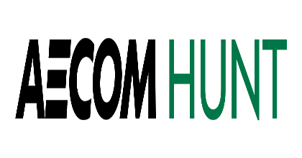

September 16, 2022

Greg Elkins

Chief Financial Officer

Mt. Vernon Community School Corporation

1806 W State Road 234

Fortville, IN 46040

**Re: Recommendation of Award for the New Fortville Elementary Project**

Dear Mr. Elkins:

AECOM Hunt has received bids for the Mt. Vernon Community School Corporation (MVCSC) “New Fortville Elementary Project – Early Release” as designed by Lancer + Beebe, LLC, on August 16, 2022 at 11:00 AM EST.

On August 17th & 18th, we held de-scope meetings with the low bidders. Based on our review of these bids and the de-scope meetings held, we are recommending award to the bidder listed below. The amount below includes Alternates #1 and #2.

BP #04 - Roofing award to Insley Systems, Inc.

Base bid amount $ 1,692,000

Alternate #1 – Provide 20-yr RoofSmart $ 160,000

Performance Warranty

Alternate #2 – Reduce roof section insulation $ (125,000)

to two layers of 2”

**Total Recommended Award $ 1,727,000**

Please advise should you have any further comments or questions relative to the above.

Sincerely,

AECOM HUNT Moisture Management Lancer + Beebe, LLC



James D. Gulley Brennen Baker Mark Beebe

Project Executive President Principal in Charge

CC: Jack Parker – MVCSC

Chris Smedley – MVCSC

Derek Shelton - MVCSC

Eric Howe – AECOM Hunt

Luke Johnson – AECOM Hunt

Wyatt May – AECOM Hunt

Justin Wolf – AECOM Hunt

Terry Lancer – L+B, LLC

Misha Belyayev – L+B, LLC

Michele Leach – Moisture Management